

Discovr Press Kit (iOS)

Founder: Pranav Kasetti

Contact Number: +44 7863908381

Website: www.discov-rr.com

Address:

2 Homestead Road,

Orpington,

Kent,

BR6 6HW

Based in United Kingdom

What is Discovr?

Discovr is a YouTube video discovery platform to collect educational content that inspires you and increases your general knowledge. Discovr for iOS is a free iPhone app that allows you to watch ad-free videos, handpick video on the go, and sync with your YouTube watch later playlist.

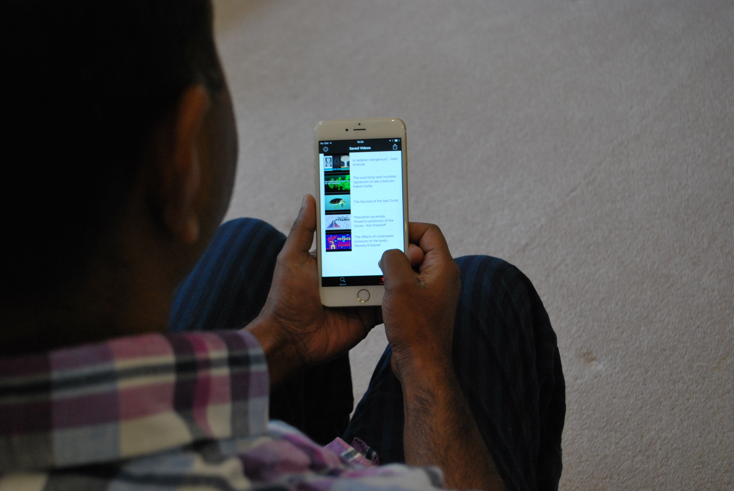

App Icon



Features

Discover educational video content

Keep informed with the opinions of thought leaders through relevant TED talks, and learn new topics with educational content.

Tinder-style video browsing

Using the app is intuitive, tap a video card to watch the video in-app, swipe a video card left or right to dismiss or save for later respectively.

Organise your video collection

The app saves the videos you liked from the main screen and lets you delete your videos if you change your mind about the video.

Undo video selections (Available via In-App Purchase)

If you change your mind about a video selection you can undo it and reselect it.

Sync with YouTube watch later playlist

After signing in with Google, and granting the app permission to change your video playlists you can sync videos discovered in the app to your watch later playlist

Keyword based recommendations

Optionally you can further personalise your video recommendations based on keywords you type into the app.

Screenshots

